**SecureShe - Real Time Women Safety**

**Alert System**

*Submitted for partial fulfillment of the requirements*

*for the award of*

**BACHELOR OF TECHNOLOGY**

in

**ARTIFICIAL INTELLIGENCE & MACHINE LEARNING**

by

**M.SAI DEEPTHI - 21BQ1A6142**

**C.LEELA MANJUNATH - 21BQ1A6115**

**M.REVANTH - 21BQ1A6141**

**N.PRASANNA KUMAR - 22BQ5A6104**

Under the guidance of

**Mrs. N.NALINI KRUPA**

 **Assistant Professor**

**DEPARTMENT OF ARTIFICIAL INTELLIGENCE &**

**MACHINE LEARNING**

(B. Tech Program is Accredited by NBA)

**VASIREDDY VENKATADRI INSTITUTE OF TECHNOLOGY**

Permanently Affiliated to JNTU Kakinada, Approved by AICTE

Accredited by NAAC with ‘A’ Grade, ISO 9001:2008 Certified

NAMBUR (V), PEDAKAKANI (M), GUNTUR – 522 508

Tel no: 0863-2118036, url: www.vvitguntur.com

March-April 2025

VASIREDDY VENKATADRI INSTITUTE OF TECHNOLOGY



Permanently Affiliated to JNTUK, Kakinada, Approved by AICTE

Accredited by NAAC with ‘A’ Grade, ISO 9001:20008 Certified

Nambur, Pedakakani (M), Guntur (Gt) -522508

DEPARTMENT OF CSE- ARTIFICIAL INTELLIGENCE& MACHINE LEARNING

**CERTIFICATE**

This is to certify that this **Project Report**  is the Bonafide work of **Ms. M.Sai Deepthi,** **Mr.C.Leela Manjunath,Mr. M.Revanth,Mr.N.Prasanna Kumar** bearing Registration.No. **21BQ1A6142, 21BQ1A6115, 21BQ1A6141, 22BQ5A6104** respectively who had carried out the project entitled **“ SecureShe-Real Time Women Safety Alert System "** under our supervision.

**Project Guide Head of the Department**

(Mrs.N.Nalini Krupa, Associate Professor) (Dr. K. Suresh Babu , Professor)

**Submitted for Viva voce Examination held on**

**Internal Examiner External Examiner**

**DECLARATION**

We, Ms. Myla Sai Deepthi, Mr. Chimirela Leela Manjunath, Mr. Munagala Revanth,

Mr. Nandigam Prasanna Kumar hereby declare that the Project Report entitled

“**SecureShe-Real Time Women Safety Alert System**” done by us under the guidance

of Mrs. N.Nalini Krupa, Associate Professor, CSE-Artificial Intelligence & Machine

Learning at Vasireddy Venkatadri Institute of Technology is submitted for partial

fulfillment of the requirements for the award of Bachelor of Technology in

Computer Science Engineering - Artificial Intelligence & Machine Learning .The

results embodied in this report have not been submitted to any other University for

the award of any degree.

DATE :

PLACE : Nambur

SIGNATURE OF THE CANDIDATE (S)

Myla Sai Deepthi,

Chimirela Leela Manjunath,

Munagala Revanth,

Nandigam Prasanna Kumar

**ACKNOWLEDGEMENT**

We take this opportunity to express my deepest gratitude and appreciation to all those people who made this project work easier with words of encouragement, motivation, discipline, and faith by offering different places to look to expand my ideas and helped me towards the successful completion of this project work.

First and foremost, we express my deep gratitude to **Sri. Vasireddy Vidya Sagar**, Chairman, Vasireddy Venkatadri Institute of Technology for providing necessary facilities throughout the B.Tech programme.

We express my sincere thanks to **Dr. Y. Mallikarjuna Reddy**, Principal, Vasireddy Venkatadri Institute of Technology for his constant support and cooperation throughout the B.Tech programme.

We express my sincere gratitude to **Dr. K. Suresh Babu**, Professor & HOD, Computer Science Engineering – Artificial Intelligence & Machine Learning Vasireddy Venkatadri Institute of Technology for his constant encouragement, motivation and faith by offering different places to look to expand my ideas.

We would like to express my sincere gratefulness to our Guide **Mrs.N.Nalini Krupa**, Associate Professor, CSE-Artificial Intelligence & Machine Learning for her insightful advice, motivating suggestions, invaluable guidance, help and support in successful completion of this project.

We would like to express our sincere heartfelt thanks to our Project Coordinator

**Mrs. N.Nalini Krupa**, Associate Professor, CSE-Artificial Intelligence & Machine Learning for her valuable advices, motivating suggestions, moral support, help and coordination among us in successful completion of this project.

We would like to take this opportunity to express my thanks to the **Teaching and Non- Teaching** Staff in the Department of Computer Science Engineering -Artificial Intelligence and Machine Learning, VVIT for their invaluable help and support.

**Name (s) of Students**

**Myla Sai Deepthi,**

**Chimirela Leela Manjunath,**

**Munagala Revanth,**

**NandigamPrasanna Kuma**

**TABLE OF CONTENTS**

|  |  |  |
| --- | --- | --- |
| **CH NO** | **Title** | **Page No** |
|  | Contents |  |
|  | List of Figures |  |
|  | Nomenclature |  |
|  | Abstract |  |
| **1** | **INTRODUCTION** |  |
| 1.1 | Women Safety in Public Spaces |  |
| 1.2 | Role of AI in Surveillance |  |
| 1.3 | What is Deep Learning? |  |
| 1.4 | Deep Learning Applications |  |
| 1.5 | What is YOLO? |  |
| 1.6 | Gesture Recognition with Mediapipe |  |
| 1.6.1 | What is Mediapipe? |  |
| 1.6.2 | How Gesture Recognition Works? |  |
| 1.6.3 | Benefits of Mediapipe |  |
| 1.7 | Telegram API for Real-Time Alerts |  |
| 1.8 | Aim and Objectives |  |
| 1.9 | Features of the Proposed System |  |
| 1.10 | Existing System Limitations |  |
| 1.11 | Overview of YOLOv11 and Gender Detection Model |  |
| 1.12 | SOS Gesture Detection Algorithm |  |
| 1.13 | Group Alert and Lone Female Detection Logic |  |
| 1.14 | Alert Messaging Workflow (Telegram Bot) |  |
| 1.15 | System Architecture |  |
| **2** | **LITERATURE REVIEW** |  |
| **3** | **PROPOSED SOLUTION** |  |
| 3.1 | Application Overview |  |
| 3.2 | Dataset and Model Integration |  |
| 3.3 | Alert Triggering Mechanism |  |
| **4** | **IMPLEMENTATION DETAILS** |  |
| 4.1 | YOLO Model Integration |  |
| 4.2 | Mediapipe Gesture Module |  |
| 4.3 | Telegram Bot Setup |  |
| 4.4 | Real-Time Video Processing with OpenCV |  |
| **5** | **RESULTS** |  |
| **6** | **CONCLUSION AND FUTURE SCOPE** |  |
| **7** | **REFERENCES** |  |
|  | **APPENDIX** |  |

**LIST OF FIGURES**

|  |  |  |
| --- | --- | --- |
| **Figure No** | **Figure Name** | **Page No** |
|  | Use Case Diagram |  |
|  | Class Diagram |  |
|  | Sequence Diagram |  |
|  | Activity Diagram |  |
|  | Collaborative Diagram |  |
|  | Component Diagram |  |
|  | Deployment Diagram |  |
|  | State Chart Diagram |  |
|  | ER Diagram |  |
|  | DFD Diagram |  |
|  | System Overview |  |
|  | YOLOv11 detection workflow |  |
|  | Mediapipe Hand Landmark Points |  |
|  | Telegram Alert Message Format |  |
|  | Features of Women Safety System |  |
|  | Existing System Issues |  |
|  | Weapon Detection Bounding Box Example |  |
|  | SOS Gesture Detection Example |  |
|  | Group Alert (Multiple Males Detected) |  |
|  | Telegram Bot Integration Diagram |  |
|  | Architecture of the System |  |
|  | Flow Diagram of Detection and Alerting |  |
|  | YOLO Detection Output Frame |  |
|  | Gesture Recognition Output Frame |  |
|  | Alert Sent to CCTV Operator Screenshot |  |
|  | Detection Accuracy Graph |  |
|  | Alert Response Time Chart |  |

**NOMENCLATURE**

|  |  |
| --- | --- |
| ML | Machine Learning |
| DL | Deep Learning |
| ER | Entity Relationship |
| DFD | Data Flow Diagram |
| YOLOv11 | You Only Look Once (Version 11.0) |
| AI | Artificial Intelligence |

**ABSTRACT**

Women Safety Analytics is a cutting-edge, AI-powered solution that leverages real-time monitoring to detect and prevent potential threats to women's safety. By incorporating computer vision, deep learning, and gesture recognition technologies, this software continuously analyses environments to detect suspicious or unsafe situations, particularly for women. It employs a combination of person detection, gender classification, anomaly detection, and predictive analytics to identify potential threats and trigger timely alerts.

The system will monitor public spaces, streets, and other critical areas to count the number of men and women present, providing insights into gender distribution patterns at specific times and locations. It is designed to identify risky situations such as a lone woman at night, a woman surrounded by men, or unusual gestures indicating distress. By offering real-time data and early alerts, Women Safety Analytics empowers law enforcement to respond swiftly and prevent potential incidents before they escalate.

Existing systems for women's safety include CCTV surveillance, mobile safety apps, AI-powered anomaly detection, and public safety hotlines. CCTV and AI systems often provide reactive monitoring, requiring manual intervention, while mobile apps and hotlines depend on victims actively requesting help, which may not always be possible. These solutions lack specific focus on detecting threats to women, relying more on generic anomaly detection or post-incident response.

Our proposal, focuses on proactive real-time threat detection using AI-powered surveillance and advanced analytics specifically designed for women's safety. By leveraging computer vision, deep learning, and gesture recognition, the system continuously monitors public spaces to detect individuals and classify gender. It provides insights into gender distribution and identifies potentially unsafe situations, such as a lone woman at night or a woman surrounded by men. The software also recognizes distress gestures (SOS) and triggers alerts without requiring manual input, allowing for faster law enforcement response. Women safety analytics should include the following functionalities 1. Person detection along with Gender Classification 2. Gender Distribution : Count the number of men and women present in the scene 3. Identifying a Lone Woman at Night time 4. Detection of a Woman Surrounded by Men 5. Recognizing SOS situation through gesture analytics.6.Weapon detection.

kEYWORDS : Computer Vision ,Deep Learning ,Real-Time Monitoring , YOLOv11 Detection ,Gesture Recognition , Mediapipe , Gender Classification ,Person Detection, Weapon Detection ,SOS Gesture Detection ,OpenCV ,Machine Learning.

**CHAPTER 1**

**INTRODUCTION**

**1.1 Women Safety in Public Spaces**

Ensuring the safety and security of women in public spaces is a critical aspect of creating an inclusive, equitable, and progressive society. Public spaces such as streets, parks, public transport, markets, and educational institutions are essential for women to participate fully in social, economic, and cultural life. However, in many regions, women face significant safety concerns, including harassment, stalking, assault, and other forms of gender-based violence, which restrict their freedom of movement and participation.

Studies and surveys globally have shown that many women alter their behavior-such as avoiding certain areas, changing routes, or limiting travel during certain times—due to fear of harassment or attack. This constant vigilance not only affects their mental well-being but also imposes social and economic constraints, limiting their opportunities and overall quality of life.

While traditional safety measures like increased police patrolling, CCTV surveillance, and public awareness campaigns contribute to women's safety, these measures often tend to be reactive rather than proactive. Many incidents go unreported or unnoticed due to the limitations of manual monitoring and delayed response times.

Technological advancements, especially in the fields of Artificial Intelligence (AI) and Computer Vision, have paved the way for smarter, real-time safety solutions. These technologies can significantly enhance the effectiveness of public surveillance systems by detecting and predicting threats, enabling immediate alerts and faster response. Integrating AI with existing infrastructure can shift safety strategies from post-incident action to real-time threat prevention, empowering law enforcement agencies and communities to create safer environments for women.

Specifically designed AI-based safetysystems can analyze crowd dynamics, identify risky gender ratios, recognize distress gestures, and detect weapons enhancing situational awareness and allowing law enforcement to respond swiftly, thereby preventing escalation and ensuring a safer public environment for women.

In this context, AI-powered women safety analytics systems play a crucial role in bridging the gap between surveillance and safety by providing continuous, intelligent monitoring specifically designed to recognize and address threats to women's security in public spaces.

**1.2 Role of AI in Surveillance**

Artificial Intelligence (AI) is revolutionizing the field of surveillance by enabling systems to move beyond passive monitoring to intelligent, proactive, and real-time analysis. Traditional surveillance systems, which rely heavily on human operators to monitor CCTV feeds and detect unusual activities, are often limited by factors such as fatigue, delayed response times, and oversight due to the sheer volume of data. AI addresses these challenges by automating the analysis of video streams, recognizing patterns, and detecting anomalies that may indicate potential threats.

AI-powered surveillance systems leverage technologies such as Computer Vision, Machine Learning, and Deep Learning to interpret visual data similarly to the human eye, but with enhanced speed and accuracy. These systems can perform tasks like object detection, facial recognition, license plate reading, and motion tracking, allowing for efficient monitoring of public spaces, transportation hubs, and critical infrastructure. By identifying specific events such as unauthorized entry, loitering, or the presence of dangerous objects like weapons AI enables faster decision-making and automated alert generation, significantly reducing reliance on manual intervention.

In the context of women’s safety, AI enhances surveillance by providing context-aware monitoring that can identify gender-based threats in real time. For instance, AI can detect scenarios such as a lone woman being followed, distress gestures (e.g., SOS signals), or suspicious group dynamics, such as a woman surrounded by multiple men. Moreover, AI systems can be integrated with alert mechanisms (e.g., SMS, emails, or messaging bots) to notify authorities or security personnel instantly, ensuring timely intervention. The use of AI in surveillance not only increases operational efficiency but also contributes to preventive security, shifting the focus from post-event analysis to real-time threat prevention.



Fig 1.1:AI in Surveillance

**1.3 What is Deep Learning?**

Deep learning is a subset of machine learning which is based on artificial neural network architecture. An artificial neural network or ANN uses layers of interconnected nodes called neurons that work together to process and learn from the input data. In a fully connected Deep neural network, there is an input layer and one or more hidden layers connected one after the other. Each neuron receives input from the previous layer neurons or the input layer. The output of one neuron becomes the input to other neurons in the next layer of the network, and this process continues until the final layer produces the output of the network. The layers of the neural network transform the input data through a series of nonlinear transformations, allowing the network to learn complex representations of the input data.

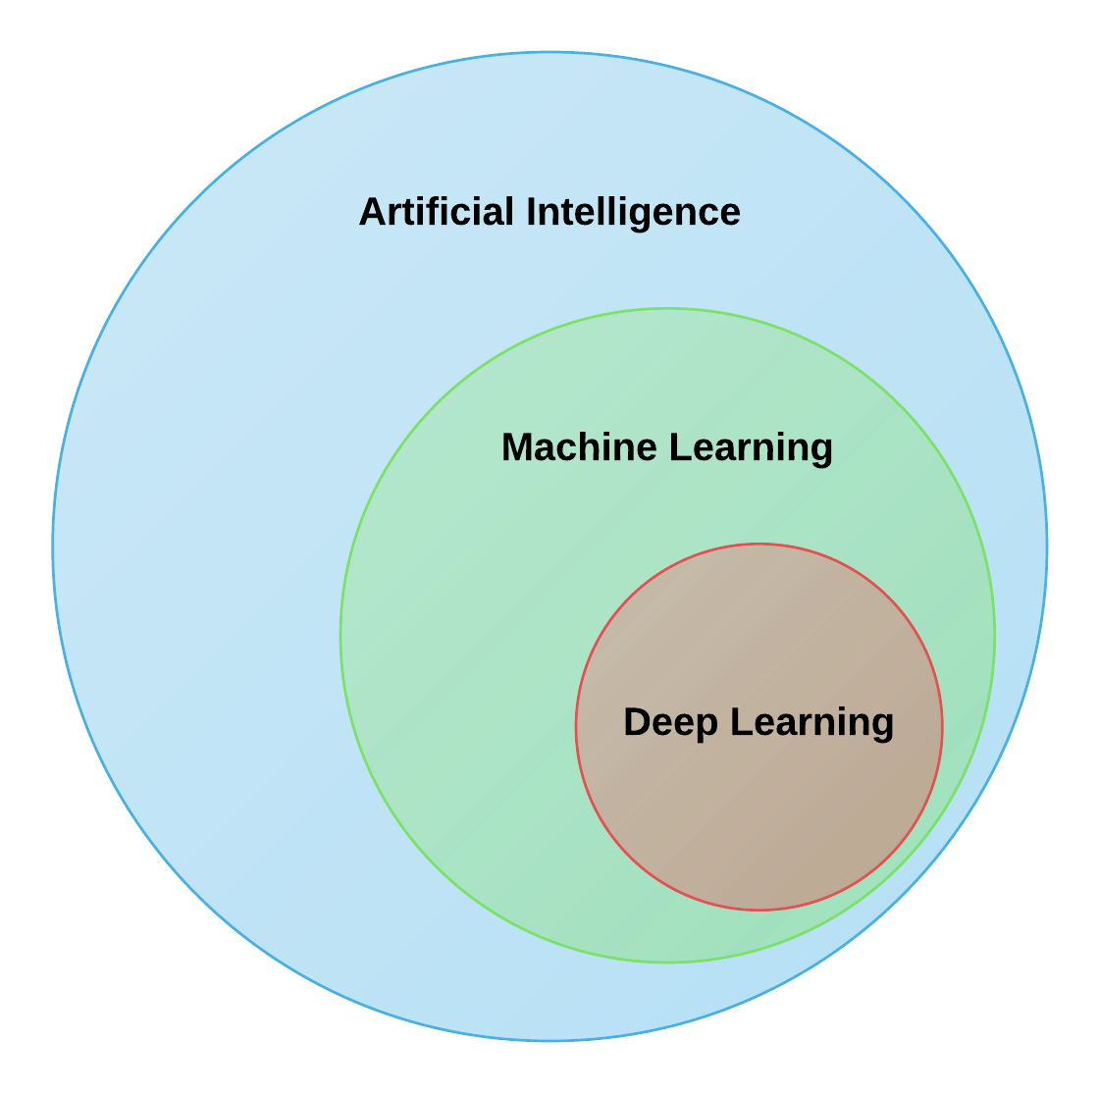

Fig1.2:DeepLearning

Deep learning can be used for supervised, unsupervised as well as reinforcement machine learning. it uses a variety of ways to process these.

**Supervised Machine Learning:** Supervised machine learning is the machine learning technique in which the neural network learns to make predictions or classify data based on the labeled datasets. Here we input both input features along with the target variables. the neural network learns to make predictions based on the cost or error that comes from the difference between the predicted and the actual target, this process is known as backpropagation. Deep learning algorithms like Convolutional neural networks, Recurrent neural networks are used for many supervised tasks like image classifications and recognization, sentiment analysis, language translations, etc.

**Unsupervised Machine Learning:** Unsupervised machine learning is the machine learning technique in which the neural network learns to discover the patterns or to cluster the dataset based on unlabeled datasets. Here there are no target variables. while the machine has to self- determined the hidden patterns or relationships within the datasets. Deep learning algorithms like autoencoders and generative models are used for unsupervised tasks like clustering, dimensionality reduction, and anomaly detection.

**Reinforcement Machine Learning:** Reinforcement Machine Learning is the machine learning technique in which an agent learns to make decisions in an environment to maximize a reward signal. The agent interacts with the environment by taking action and observing the resulting rewards. Deep learning can be used to learn policies, or a set of actions, that maximizes the cumulative reward over time. Deep reinforcement learning algorithms like Deep Q networks and Deep Deterministic Policy Gradient (DDPG) are used to reinforce tasks like robotics etc.

**1.4 DEEP LEARNING APPLICATIONS**

The main applications of deep learning can be divided into computer vision, natural language processing (NLP), and reinforcement learning.

**Computer vision:**

In computer vision, Deep learning models can enable machines to identify and understand visual data. Some of the main applications of deep learning in computer vision include:

• Object detection and recognition: Deep learning model can be used to identify and locate objects within images and videos, making it possible for machines to perform tasks such as self-driving cars, surveillance, and robotics.

• Image classification: Deep learning models can be used to classify images into categories such as animals, plants, and buildings. This is used in applications such as medical imaging, quality control, and image retrieval.

• Image segmentation: Deep learning models can be used for image segmentation into different regions, making it possible to identify specific features within images.

**1.5 What is YOLO?**

YOLO (You Only Look Once) is a cutting-edge, real-time object detection algorithm that has revolutionized the field of computer vision and deep learning. Unlike traditional object detection systems that repurpose classifiers or localizers to perform detection, YOLO frames object detection as a single regression problem, directly predicting bounding boxes and class probabilities from an image in one evaluation. This unified approach allows YOLO to be extremely fast and efficient, making it highly suitable for real-time applications like surveillance, autonomous vehicles, robotics, and security systems.

The main advantage of YOLO is that it processes the entire image at once, taking into account the global context, rather than scanning different parts of the image separately like earlier methods (e.g., R-CNN, Fast R-CNN). This leads to significantly faster detection speeds while maintaining high accuracy. YOLO divides an input image into a grid and for each grid cell, it predicts bounding boxes, confidence scores, and class labels simultaneously. This real-time capability is crucial for tasks like threat detection, weapon recognition, and people counting in dynamic environments.

Over time, YOLO has evolved through multiple versions-YOLOv1 to YOLOv11 each improving on speed, accuracy, and versatility. The latest versions, such as YOLOv11, support advanced features like instance segmentation, multi-object tracking, and improved model efficiency, making them ideal for AI-powered surveillance systems. In the context of women’s safety analytics, YOLO plays a critical role in detecting people, classifying gender, identifying the presence of weapons, and analyzing crowd patterns, thereby enabling proactive threat detection and real-time alerts.

YOLO (You Only Look Once) is a state-of-the-art, real-time object detection algorithm that is widely used in computer vision applications. It is designed to detect and classify multiple objects in an image or video frame in a single pass, making it highly efficient for real-time tasks like video surveillance, autonomous vehicles, and security monitoring.

How YOLO Works:

YOLO divides an input image into a grid system and, for each grid cell, it predicts:

* Bounding boxes (to locate objects)
* Confidence scores (probability that an object exists)
* Class probabilities (to classify detected objects)

All of this happens in one evaluation of the neural network, making YOLO exceptionally fast and accurate.

**YOLO in Our Project**

In our project, YOLOv11 and YOLOv8 models are used to:

* Detect people and classify them by gender
* Detect weapons in real-time
* Enable real-time alerts when unsafe conditions are detected (e.g., a lone woman at night, or a woman surrounded by men)

By integrating YOLO, your system achieves instantaneous detection and decision-making, ensuring swift alert generation to CCTV operators or law enforcement, thereby enhancing proactive threat prevention.

**1.6 Gesture Recognition with Mediapipe**

Gesture recognition is an essential feature in modern AI-powered surveillance systems, especially for applications involving human-computer interaction and safety analytics. In the context of women’s safety, recognizing specific hand gestures like SOS signals can play a critical role in identifying distress and triggering real-time alerts when verbal communication is not possible. One of the most powerful tools for implementing gesture recognition efficiently is Mediapipe, developed by Google.

**1.6.1 What is Mediapipe?**

Mediapipe is an open-source framework that provides cross-platform, customizable ML pipelines for live and streaming media. It includes ready-to-use solutions for hand tracking, face detection, pose estimation, object tracking, and more. For gesture recognition, Mediapipe's Hand Tracking module is widely used due to its high speed and accuracy in detecting 21 3D landmarks on each hand in real time.

**1.6.2 How Gesture Recognition Works?**

Mediapipe uses a two-step pipeline:

1. Palm Detection: Detects hand region in the frame.
2. Hand Landmark Model: Identifies 21 key points (landmarks) on the detected hand, including fingertips, knuckles, and wrist points.

Using these landmarks, gestures can be identified by calculating relative distances and angles between specific landmarks.

In our system:

* SOS Gesture is recognized when the thumb and pinky fingertips come close together.
* Thumbs Up Gesture is recognized when the thumb is raised above the index finger’s MCP joint.

Once a gesture is detected for a predefined number of frames (for confirmation), the system can trigger an alert (for SOS) or display a safe message (for thumbs up).

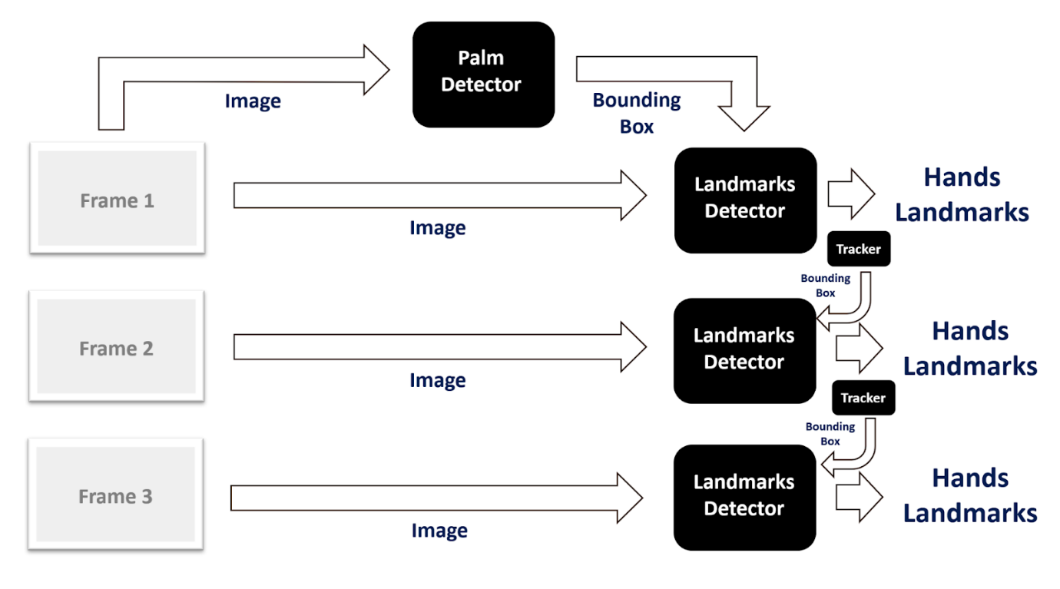

Fig 1.3:Landmark Detector

**1.6.3 Benefits of Mediapipe**

* **Lightweight & Fast**: Runs in real time even on low-resource systems.
* **Cross-Platform**: Works on desktops, mobile devices, and embedded systems.
* **Highly Accurate**: Provides robust hand landmark tracking even in challenging environments.
* **No Special Hardware**: Works with standard webcams or CCTV feeds.

**1.7 Telegram API for Real-Time Alerts**

Real-time alerting is a crucial component in safety-critical applications, especially for women’s safety in public spaces. Prompt communication with security personnel or law enforcement can prevent incidents from escalating. In your system, the Telegram API plays a key role in enabling instantaneous alerts by delivering messages, images, and location information directly to CCTV operators or concerned authorities.

**What is Telegram API?**

The Telegram Bot API allows developers to create bots that interact with users or groups through the Telegram messaging platform. These bots can send messages, images, videos, documents, and even trigger interactive commands, making them ideal for automated alerting systems.

**Benefits of Telegram API for Real-Time Alerts**

* Instant Communication: Messages are delivered within seconds, ensuring fast response.
* Multimedia Support: Ability to send images, videos, and audio, giving context to the alert.
* Cross-Platform: Telegram is accessible on PC, mobile, and web, allowing operators to stay connected anywhere.
* Secure & Reliable: Telegram uses end-to-end encryption and has a robust infrastructure for high reliability.
* Scalability: Easily supports multiple operators, group notifications, and custom alert formats**.**

**1.8 Aim and Objectives**

**Aim**

To develop an AI-powered Women Safety Analytics System that leverages real-time surveillance, computer vision, and gesture recognition to proactively detect and prevent potential threats to women’s safety in public spaces, and to deliver instant alerts to CCTV operators for timely intervention.

**Objectives**

1. To implement real-time person detection using **YOLO object detection models** to identify individuals within a surveillance feed.
2. To classify detected individuals by gender, enabling gender distribution analysis in public areas for identifying potentially risky environments.
3. To detect critical situations, including:
   * **A lone woman in a public space during night hours**.
   * **A woman surrounded by a group of men**.
   * **Presence of weapons indicating immediate threats.**
4. To integrate **gesture recognition** using Mediapipe, allowing the system to detect SOS gestures (e.g., thumb and pinky together) that indicate distress without the need for verbal communication.
5. To develop an automated alert system using the Telegram Bot API to send real-time notifications with captured images and location details to CCTV operators or security personnel.
6. To reduce manual surveillance workload by providing an AI-driven, proactive monitoring system that focuses specifically on women's safety scenarios.
7. To analyze time-based and location-based data, offering insights into gender distribution trends and potentially unsafe zones for women, assisting in long-term safety planning.

**1.9 Features of the Proposed System**

The proposed Women Safety Analytics System is an advanced AI-based surveillance solution that integrates real-time video analysis, gesture recognition, and automated alerting to proactively detect and respond to threats against women in public spaces. It is designed to overcome the limitations of existing safety tools by offering intelligent, context-aware monitoring and rapid communication with authorities.

**Key Features**

**a. Real-Time Person Detection and Gender Classification**

* Uses YOLO object detection models to accurately detect individuals in video feeds.
* Classifies detected individuals as male or female using trained deep learning models.
* Enables instant analysis of gender distribution in public areas.

**b. Gender Distribution Monitoring**

* Counts the number of males and females present in a scene.
* Highlights gender imbalance (e.g., a woman surrounded by multiple men), identifying potentially unsafe situations.
* Offers time- and location-based insights into crowd demographics.

**c. Lone Woman Detection During Night Hours**

* Detects a solitary female in public spaces between 10 PM and 5 AM, a time considered high-risk.
* Triggers alerts to CCTV operators for immediate attention and intervention.

**d. Detection of Woman Surrounded by Men**

* Identifies when male count exceeds female count significantly, particularly when a single female is present.
* Sends real-time alerts with images to notify potential crowd threats.

**e. SOS Gesture Recognition Using Mediapipe**

* Recognizes distress gestures like the SOS hand sign (thumb and pinky touching).
* Employs gesture analytics for non-verbal communication in emergencies.
* Triggers instant alerts with image evidence without requiring manual input.

**f. Weapon Detection**

* Utilizes a custom YOLO model to identify weapons (e.g., knives, guns) in real time.
* Sends alerts with captured frames to ensure swift response from law enforcement.

**g. Automated Real-Time Alerts via Telegram API**

* Sends instant notifications to CCTV operators through Telegram bot, including:
  + Alert description.
  + Captured image of the incident.
  + Camera location.
* Ensures immediate awareness and response, reducing escalation risks.

**h. Hands-Free Operation and Continuous Monitoring**

* Requires no manual input; operates autonomously.
* Designed for continuous 24/7 monitoring, ensuring round-the-clock safety analytics.

**i. Scalable and Adaptable**

* Can be deployed across multiple camera feeds.
* Adaptable for smart cities, public transit hubs, campuses, and urban areas.

**1.10 Existing System Limitations**

While various systems exist to address public safety, most traditional surveillance solutions and women safety tools have significant limitations when it comes to proactive threat detection, especially in the context of women’s safety in public spaces. These limitations reduce their effectiveness in preventing incidents and providing real-time support.

**1. Manual Monitoring Overload**

Conventional CCTV systems rely heavily on human operators to constantly monitor video feeds. Due to human fatigue, attention lapses, and the sheer volume of surveillance footage, critical events can be missed, resulting in delayed responses or unnoticed threats.

**2. Reactive Instead of Proactive**

Most existing systems are reactive, meaning they are used primarily for post-incident investigation rather than real-time prevention. Footage is reviewed after an event occurs, offering no immediate support to victims in distress.

**3. Lack of Context-Aware Analysis**

Traditional systems do not provide context-aware monitoring. For example, they cannot distinguish between a normal gathering and a potentially risky situation, such as a lone woman at night or a group of men surrounding a female. There is no gender-based analysis or situational interpretation in basic surveillance setups.

**4. Dependency on Victim’s Actions**

Mobile safety apps and emergency hotlines require active input from victims (e.g., pressing an SOS button, making a call). In many real-world scenarios, women may be unable to access their phone or communicate distress due to fear, coercion, or immediate danger.

**5. Generic Anomaly Detection**

Some AI-based systems use general anomaly detection algorithms, which can identify unusual movement or behavior but lack specialization in detecting gender-based threats or specific gestures of distress like an SOS sign.

**6. No Integrated Alerting Mechanism**

Most systems do not have automated alert systems connected to authorities. They depend on manual escalation, which slows down response time and may allow threats to escalate.

**1.11 Overview of YOLOv11 and Gender Detection Model**

**YOLOv11 Object Detection Model**

YOLOv11 (You Only Look Once, Version 11) is an advanced version of the popular YOLO object detection family. Though officially, the latest release is YOLOv8 by Ultralytics, YOLOv11 likely indicates a custom-trained or experimental version based on YOLOv8, optimized for specific tasks like person detection, weapon detection, and gender classification.

The core idea of YOLO remains: real-time object detection in a single forward pass through the neural network. It divides the input image into grids and predicts bounding boxes, object classes, and confidence scores for each grid cell, allowing fast and accurate detection in dynamic environments like CCTV surveillance.

**Custom Gender Detection Model (best_y11.pt)**

In our project, a custom model named best_y11.pt is used for gender classification. This model is likely trained using YOLO’s transfer learning capabilities on a dataset of labeled images (Male, Female) to achieve optimized performance in real-world CCTV footage.

**Key Features:**

* Input: Real-time video frames from CCTV or webcam.
* Output: Bounding boxes around detected persons, labeled as Male or Female.
* Confidence Threshold: Only predictions with >70% confidence are considered valid for gender classification.
* Color Coding: Females in blue boxes, Males in green boxes.

**Model Workflow in our System:**

1. Frame Capture: A frame is taken from a video feed.
2. Detection: The gender_model (best_y11.pt) runs on the frame.
3. Counting: The model counts male and female instances.
4. Alert Logic: Based on the gender count:
   * If more men than women → Group Alert.
   * If single female at night → Lone Woman Alert.

**Integration Benefits:**

* **Fast Inference**: Enables real-time decision making.
* **High Accuracy**: Custom-trained for real-world gender detection.
* **Scalable**: Can be applied to multiple video streams.
* **Lightweight**: Optimized for deployment on edge devices or central servers.

**Confusion Matrix Analysis – Gender Detection Model**

* The confusion matrix shown above provides a comprehensive overview of the performance of our YOLOv11-based gender detection model across three classes: Class 0 (Male), Class 1 (Female), and Background.

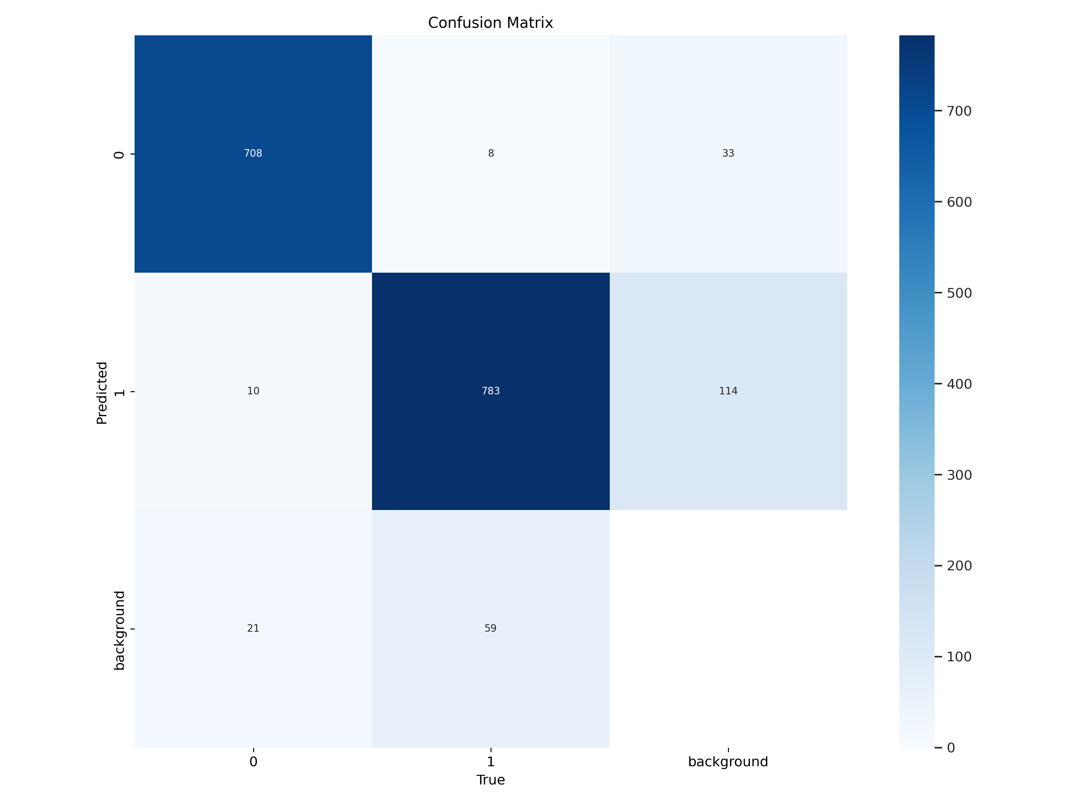

**High Accuracy for Male and Female Detection:**

* Out of all actual male instances, 708 were correctly classified, with only minor misclassifications.
* Out of all actual female instances, 783 were correctly classified, though 114 were misclassified as background.

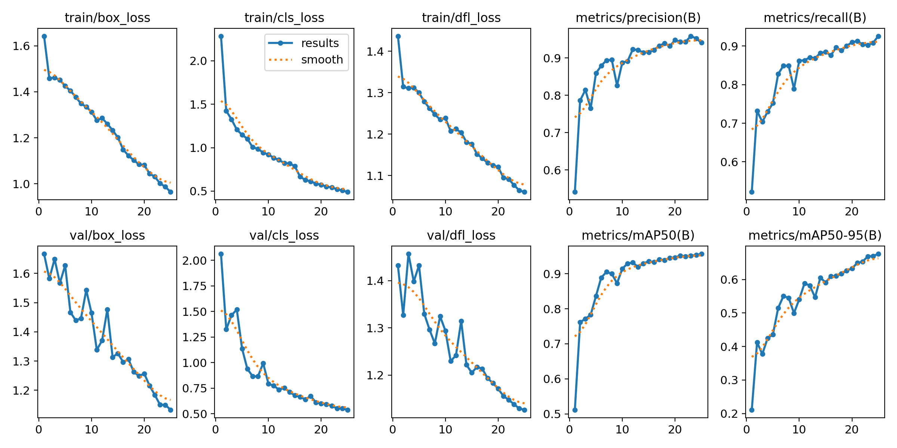

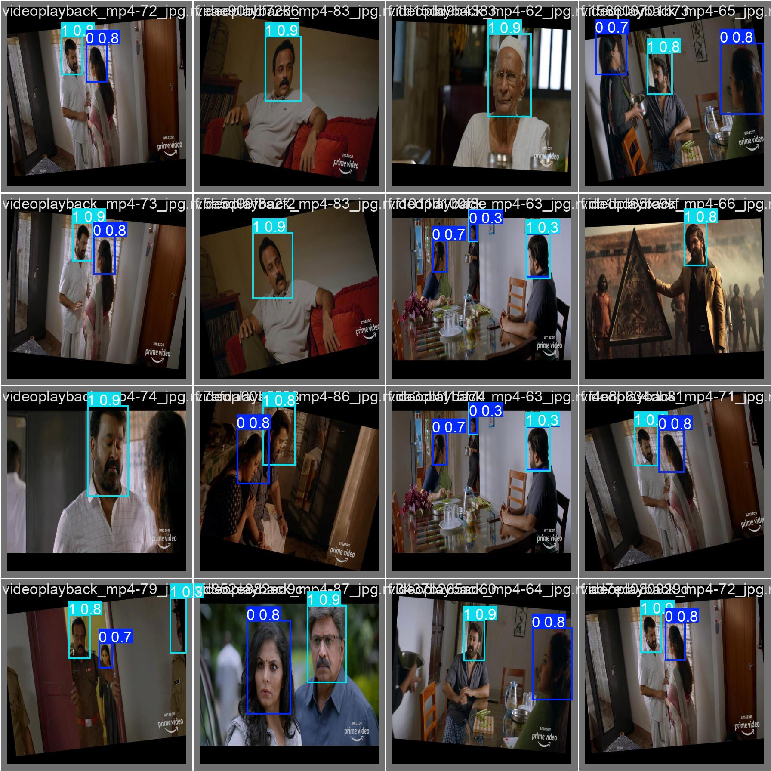

**1.12 SOS Gesture Detection Algorithm**

**Objective:**

To recognize a specific hand gesture (e.g., raising both hands or showing a predefined SOS sign) using a webcam or CCTV feed and trigger an emergency alert through a Telegram bot or SMS system.

**Step-by-Step Algorithm:**

1. **Initialize Environment:**
   * Import required libraries: cv2, mediapipe, telepot, and others.
   * Configure the Telegram bot with chat_id and API token.
   * Initialize the camera and Mediapipe’s hand detection module.
2. **Start Video Capture Loop:**
   * Capture frame-by-frame input from the webcam.
   * Flip the frame horizontally for natural hand interaction.
3. **Preprocess for Gesture Detection:**
   * Convert the BGR frame to RGB.
   * Use Mediapipe’s Hands module to detect hand landmarks.
4. **Detect Hands and Analyze Landmarks:**
   * If hand landmarks are detected:
     + Draw hand connections for visualization.
     + Extract the Thumb Tip and Pinky Tip landmarks.
     + Calculate the vertical distance between Thumb Tip and Pinky Tip.
5. **Determine SOS Gesture:**
   * Define SOS Gesture Condition:
   * Count consecutive frames where SOS gesture is detected (sos_count).
   * If SOS gesture is detected:
     + Increment sos_count, reset thumbs_up_count.
   * If gesture is not detected:
     + Reset both counts to 0.
6. **Confirm SOS with Frame Consistency:**
   * If sos_count exceeds required_frames (e.g., 5 frames):
     + Display alert text on the frame: "SOS Detected! Need Help!"
     + If sosdetectalert is not already triggered:
       - Save the frame image.
       - Send photo and alert message via Telegram bot.
       - Set sosdetectalert = 1 and reset sosresetcount = 0.
7. **Handle SOS Reset:**
   * Increment sosresetcount every loop when sosdetectalert = 1.
   * If sosresetcount > 60 (frames threshold to reset alert):
     + Reset sosdetectalert = 0.
8. **Optional: Thumbs Up Gesture Detection:**
   * Detect Thumbs Up gesture (Thumb Tip above Index MCP).
   * If detected for required frames:
     + Display "Thumbs Up, I'm Safe!" message.
9. **Display Frame:**
   * Show the annotated frame in a window.
   * Press 'q' to terminate the loop.
10. **Cleanup:**
    * Release the webcam and destroy all OpenCV windows.

**1.13 Group Alert and Lone Female Detection Logic**

**Group Alert and Lone Female Detection Logic**

**Objective:**

To detect scenarios where one female is surrounded by multiple males in real-time video feed, using a YOLOv11 model trained for gender detection. If such a situation is detected, an alert is sent via Telegram with an image of the scene.

**Step-by-Step Detection Logic:**

**1. Initialize Detection System:**

* Load the YOLOv11 model for gender detection (best_y11.pt).
* Initialize the Telegram Bot for sending real-time alerts.
* Start video capture from webcam.

**2. Frame-by-Frame Processing:**

* For each captured frame:
  + Pass the frame through the YOLO model.
  + Extract detections including:
    - Class labels (0 = Male, 1 = Female, 2 = Background or others depending on your classes).
    - Bounding boxes.
    - Confidence scores.

**3. Count Gender Occurrences:**

* Initialize counts:
  + male_count = 0
  + female_count = 0
* For each detection in the frame:
  + If class == 0 → male_count += 1
  + If class == 1 → female_count += 1

**4. Group Alert Trigger Logic:**

* **Alert Condition**:

if female_count == 1 and male_count >= 2:

Trigger Group Alert

* Rationale:
  + The presence of only one female with two or more males could indicate potential danger.

**5. Trigger Alert:**

* If the alert condition is met and groupalert == 0 (alert not already sent):
  + Save the current frame as an image.
  + Send photo and message via Telegram:
    - Example message: "Group Alert: Lone female surrounded by males detected!"
  + Set groupalert = 1 to prevent repeated alerts.
  + Reset groupresetcount = 0 to start a cooldown timer.

**6. Cooldown and Reset Mechanism:**

* Increment groupresetcount on each frame after alert.
* When groupresetcount > 100 (frames threshold):
  + Reset groupalert = 0 to allow future alerts.

**1.14 Alert Messaging Workflow (Telegram Bot)**

1. **Telegram Bot Initialization**:  
   The system uses the Telegram Bot API to send real-time alerts. The bot is initialized using a Bot Token and a Chat ID. These credentials allow the program to interact with a specific Telegram chat (group or individual) where alerts need to be delivered.
2. **Capturing the Alert Frame**:  
   When a critical event is detected (e.g., a lone female surrounded by multiple males), the current frame from the video stream is captured and saved as an image. This visual evidence is essential for verifying the alert and for any potential intervention.
3. **Composing the Alert Message**:  
   Along with the image , a text message is created . This message includes vital information such as the nature of the alert (e.g., “Group Alert: Lone female surrounded by males detected!”) and any timestamp or location data, if available, to give context to the alert.
4. **Sending Alert to Telegram**:  
   The system sends the alert via Telegram using an HTTP POST request to the Telegram Bot API. The image file and the text message are included in the request, which is directed to the specific chat using the stored Chat ID.
5. **Confirmation and Reset Mechanism**:  
   After the alert is sent, the system confirms delivery (optionally by checking the response code from Telegram)and sets a flag to avoid sending repeated alerts for the same event. A reset mechanism based on frame count or time delay ensures that the system is ready to send future alerts.
6. **Real-Time Responsiveness**:  
   This workflow ensures real-time communication of potentially dangerous situations, enabling immediate action. The automated and continuous monitoring ensures no human intervention is needed for sending alerts, thereby improving efficiency and responsiveness.

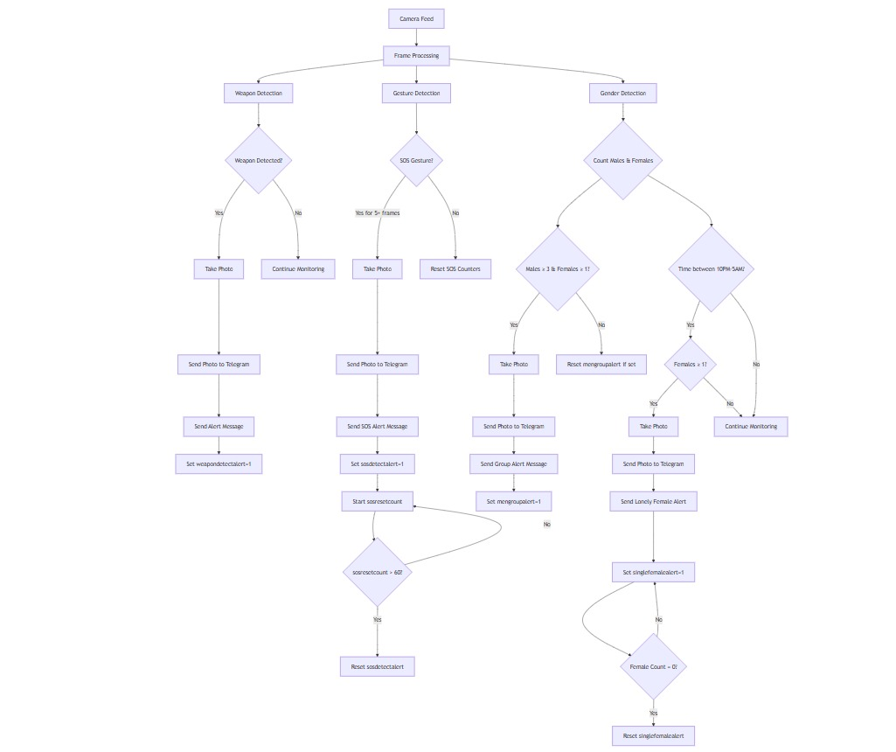

**1.15 System Architecture**

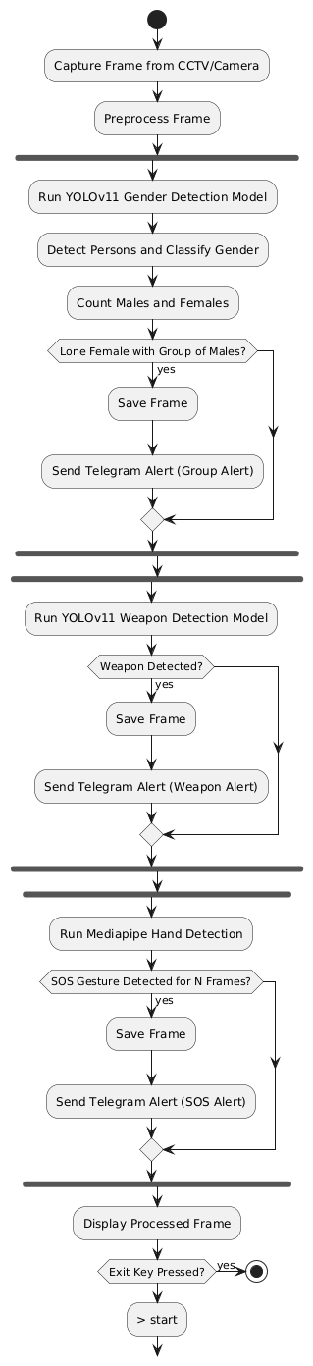

**1. Input Layer – CCTV/Camera Feed**

* The system begins with live video input from surveillance cameras or CCTV.
* Frames are extracted in real-time for analysis.

**2. Pre-processing Module**

* Captured frames undergo resizing, normalization, and color space conversion (if needed) to prepare for model input.
* Frame data is formatted for YOLOv11 and MediaPipe processing.

**3. Detection & Recognition Modules**

**a. YOLOv11 Gender Detection Model**

* YOLOv11 is used for object detection and gender classification.
* Each detected person is classified as Male, Female, or Background.
* Bounding boxes and class labels are overlaid on frames.

**b. MediaPipe Gesture Recognition**

* MediaPipe processes the same frames to detect 21 hand landmarks.
* It analyzes the hand posture to identify specific SOS gestures (e.g., hand wave or specific finger positioning).

**4. Analytical Logic Layer**

**a. Lone Female Detection**

* Counts the number of males and females in the frame.
* If only one female is surrounded by multiple males, the system flags it as a critical situation.

**b. SOS Gesture Trigger**

* If an SOS gesture is detected, it acts as a manual trigger for sending alerts, even without group logic detection.

**5. Alert & Communication Module**

**a. Telegram Bot API Integration**

* The system captures the current frame and sends a real-time alert via Telegram.
* The message includes the captured image, alert type, and optionally location or timestamp.

**6. Output & Storage**

* Alert frames can be stored locally or in a cloud database for future review.
* Logs of alerts and detected events are maintained for audit trails.

**CHAPTER 2**

**LITERATURE REVIEW**

There are several strategies that come out in existing studies to enhance the safety of woman in several conditions at public places through CCTV surveillance and we inherited some of the properties for these papers which are pre published some of them are

**Women Safety Analytics - Protecting Women from Safety Threats – Nov 2024**

Used sentimental analysis on those social media posts which are like Twitter, Facebook etc. to detect the wrong content. Integrated real-time monitoring with SWD which are smart warble devices which are equipped with GPS, microphone, and camera for safety analysis.

**AI-Powered CCTV Analytics for Proactive Threat Detection and Operational Excellence in Well Engineering Operations – Nov 2024**

Applied AI to the CCTV cameras to detect the traffic operations on the road. We used this feature which can scan the faces and detect the number of persons.

**An Integrated Approach for Real-Time Gender and Age Classification in Video Inputs Using FaceNet and Deep Learning Techniques – Aug 2024**

This is used to Classify the Gender based on the detection of the faces and this we are inspired of this feature which can classify the gender.

**Deep Learning Based Hand Gesture Recognition for Emergency Situations: A Study on Indian Sign Language – May 2021**

Used this to identify the distress gestures and signs which can be used for identifying the situation.

**Weapon Detection Using YOLO V3 for Smart Surveillance System – May 2021**

Used YOLOv3 to detect the weapon for the surveillance team.

**Towards a Conceptual Framework for AI-driven Anomaly Detection in Smart City IoT Networks for Enhanced Cybersecurity – Oct 2024**

Used to identify unusual behaviors for surveillance team.

**Real-time Object Detection, Tracking, and Monitoring Framework for Security Surveillance Systems – Aug 2024**

Evaluated YOLO and SSD models for real-time object detection, which helped to optimize our tracking of threats in public places for the surveillance team.

**Object Detection and Crowd Analysis Using Deep Learning Techniques: Comprehensive Review and Future Directions – Sept 2024**

Used to identify the count of people in crowded places which will be further classified into men and women. This will be used to detect the Conditions at where men will be more and alone woman such cases.

**Artificial Intelligence & Crime Prediction: A Systematic Literature Review – Mar 2022**

Predicts the crime before itself, based on the situations and conditions around.

**The Role of IoT in Women’s Safety – Jan 2023**

Used for Networking which helped more which sending message to Surveillance team from telegram bot.

**AI in Crime Prediction and Prevention – May 2024**

Demonstrated how AI models predict and prevent crime which helped us even more.

**A Hidden Markov Model and IoT Hybrid Based Smart Women Safety Device – Jun**

2018 Provided insights for integrating IoT with predictive models for safety monitoring for the surveillance team.

**A Machine Learning Approach to Design and Develop a BEACON Device for Women’s Safety – 2022**

May Discussed wearable safety devices powered by ML, inspiring framework. our system’s emergency response

**Guardian Device for Women—A Survey and Comparison Study – 2021**

May Compared various women safety technologies, which helped us to refine our feature selection.

**Recent and Emerging Technologies: Implications for Women’s Safety – Aug 2019**

Explored AI technologies which we have used in our system.

**IoT-based Women Security: A Contemplation – Mar 2020**

Highlighted IoT-based for refining networking in our system for the better usage.

**Systematic Literature Review vs Narrative Review – 2007**

May Provided methodological guidance for analyzing research trends in women’s safety technology.

**Smart Wearable Device for Women Safety Using IoT – Jun 2020**

In this they enabled IOT based products for woman which they will be under going continues monitoring.

**MoveFree: A Ubiquitous System to Provide Women Safety – Aug 2015**

Proposed a multi-model safety system which helped our security surveillance system for sending the messages.

**Design of a Smart Women Safety Band Using IoT and Machine Learning – May 2021**

In this they used IOT based Bands which are contributing for our IOT based frame works.